Хлебова Маргарита Юрьевна
учитель английского языка
МБОУ СОШ имени М.И. Калинина
МО «город Бугуруслан»
Название предмета: английский язык
Класс: 10
УМК: «Английский в фокусе» ("Spotlight") для 10 класса общеобразовательных учреждений (авторы О. В. Афанасьева, Д. Дули, И. В. Михеева, Б. Оби, В. Эванс), 2015
Уровень обучения: базовый
Тема урока: «Поиск работы».
Общее количество часов, отведенное на изучение темы: 2
Место урока в системе уроков по теме: 2
Цель урока: совершенствование навыков чтения, говорения, аудитивных навыков, формирование лексико-грамматических навыков по теме урока.
Задачи:
Обучающая: формировать различные виды учебного чтения, умения анализировать и обобщать; актуализировать лексический запас учащихся; совершенствовать аудитивные навыки; формировать навыки распознавания и употребления в речи различных грамматических средств для выражения будущего времени.
Развивающая: развивать умения и навыки устной речи учащихся;
Воспитательные: воспитывать интерес к изучению английского языка.
Планируемые результаты.
Учащиеся должны знать:
- значения новых лексических единиц, связанных с тематикой данного этапа обучения и соответствующими ситуациями общения.
Учащиеся должны уметь:
1. составить диалог по тематике раздела, освоить навыки распознавания и употребления в речи степеней сравнения имен прилагательных.
Техническое обеспечение урока: компьютер, проектор, презентация, аудиоприложение к учебнику «Spotlight 10», раздаточный материал.
Дополнительное методическое и дидактическое обеспечение урока: учебники, раздаточный материал, рабочие тетради к учебнику «Spotlight 10» (О.В. Афанасьева, Дж. Дули, И.В. Михеева, «Просвещение» 2016 г.).
Содержание урока
- Организационный момент.
- Приветствие.
- Good morning, students. I’m glad to see you. How are you today? Let’s start our English lesson. Sit down, please.
- What date is it today?
- What day of the week is it today?
- What is the weather like today?
- Name the jobs: which involves a lot of travelling; is 9 to 5; starts early in the morning; requires shift work; asks for a lot of responsibility.
- Сообщение целей и задач урока.
- Say which are the best and worst paid jobs?
a nurse in a hospital | a highly paid job
a shop assistant | get a good salary
a worker in a factory | overpaid
a bank manager | get a lot of money
a dentist | paid a lot
a teacher | paid reasonably well
a professional footballer | a low – paid job
a nuclear scientist | have a low income
a miner in the coalmine | underpaid

- Coming back to these phrases, what are we going to speak about today? OK. Today we’ll talk about a variety of jobs.
- Активизация лексического материала.
- Активизация лексических навыков.
- Look at ex. 4 at p. 49 and complete the idioms, try to find the Russian equivalents for these idioms.
- follow in her footsteps
- jack-of-all-trades
- in the same boat
- bring home the bacon
    - Read the following extracts from job advertisements. Complete the gaps using the words below, then match each extract (1-10) to a sentence (A-J):
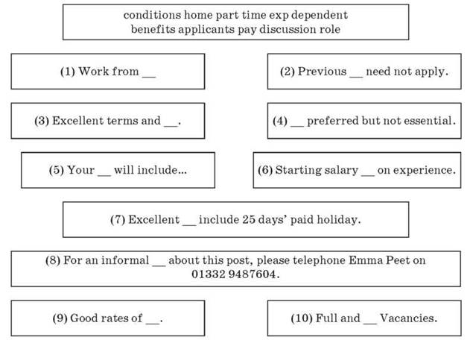
Key: 1 home; 2 applicants; 3 conditions; 4 experts; 5 role; 6 dependent; 7 benefits; 8 discussion; 9 pay; 10 part time.
A If you get the job, you will be well looked-after by the company.
B If you have applied for the same job before, please do not reapply.
C Here are some of the duties.
D If you would like to talk about the job in more detail, please contact.
E The money you will earn will vary depending on what you have done in the past.
F You can apply even if you have never done this job before.
G You will be well rewarded financially.
H There are jobs with various hours available.
I You don't need to go to work every day.
J Good annual leave entitlement is one of the perks of the job.
Key: 1 I; 2 B; 3 A; 4. F; 5 C; 6 E; 7. J; 8 D; 9 G; 10 H.
  - Речевая зарядка.
    - Your homework was to make up the dialogues using the structures from the language box.
- Pay attention to the language box and review the structures. Form your questions using the prompts and ask them each other.

    - Do you think you’ll be the bank clerk one day?
    - No, I don’t think so because I don’t think I’ll want to have a lot of responsibility.
- Практикум диалогической речи.
- Let’s read the first and the last exchanges in the dialogue from the ex. 5 at. 49. What is the relationship between the speakers? What is the dialogue about? Listen and check.
- Read the dialogue. What kind of job is Ann applying for? Which two adjectives best describe her: patient, hardworking, energetic, keen, outgoing?
Ann is applying for a job as a secretary. I think the adjectives hardworking and outgoing best describe Ann. She worked during her summer holidays from college, and doesn’t mind working long hours or weekends.
    - Which heading best describes the dialogue?

Appplying for a job. A job interview. Asking for a pay rise.
- Физминутка
- Let’s have a rest a little.
Let’s twist again like we did last summer,
Let’s twist again like we did last year.
Do you remember when things were really hummin’?
Let’s twist again, twisting time is here.
We go round and round and up and down we go again.
Baby, make me know you love me so and then.
Let’s twist again like we did last summer, yeah.
Let’s twist again twisting time is here.
- Формирование навыков аудирования.
- Sarah is being interviewed for a job in ex.8 at p. 49. Look at the interview’s notes below. What questions do you think he asked Sarah? Listen and check.
He asks her about her name, age, experience, qualities and when she will be available to start.
    - Now listen to the recording again and fill in the gaps with the correct answers.
- Sarah Hodgkins
- nearly 22
- training course
- receptionist
- good organised
- from 1st April
- Выполнение тренировочных упражнений.
    - Take one of the cards and form the appropriate future tense.

__________ you (finish) working on your project by Friday?  Answer: Will you have finished… | A: He’s got birthday today.  B: Oh, really? I ___________ (definitely call) him then.  Answer: I’ll definitely call him then | A: Any plans for the weekend?  B: Yes, I __________ (fly) to Norway. Tickets were really expensive.  Answer: I am flying
My boss ____________ (fire) me, I ____________ (not finish) by the deadline.  Answer: is going to fire OR will fire; I won’t have finished | A: Can I call you tomorrow?  B: Sure, I’ll be at home this time tomorrow. John and I __________ (clean) the house.  Answer: will be cleaning | Amanda! Look at you! You are pregnant! My congratulations! When _________ (have) a baby?  Answer: are you going to have/ are you having
When __________ your train (leave)?  Answer: does your train leave | A: When _____________ you (see) your doctor?  B:Tomorrow at 12.  Answer: are you seeing | In far future, say by 2100, they __________ (make) a robot to substitute a human at war.  Answer: will have made
What ___________ you (do) tomorrow?  Answer: are you going to do | A: Come to the cinema with us.  B: I can’t. I’ve taken extra shift at hospital, so ___________ (work) tonight.  Answer: am working/ will be working | The bus ___________ (arrive) at 10, we need to make it in time, otherwise I ________ (have to stay) here till Monday.  Answer: arrives/will have to
If it _________ (happen) in future, I __________ never (go) with you to the market again.  Answer: happens/ will never go | What _________ (do) at 12 o’clock tomorrow?  Answer: will you be doing | Watch out! That ladder is shaking. It _____________ (fall).  Answer: it is going to fall
I ________ (bring) your book tomorrow. I promise.  Answer: I’ll bring | It is hot in here. _______ I (open) the window?  Answer: Shall I open | My parents __________ (visit) tonight, they live in Turkey. They haven’t been here for 4 years.  Answer: are visiting
Next three years he _________ (work) for his father. We’ll see how it goes.  Answer: he will be working | I think soon it ________ (get) easier to travel to Space.  Answer: will get | By the time you _________ (buy) this book, I _______ (finish) reading it.  Answer: you buy/ I will have finished

    - Write the horoscope using Future tenses.
Aries | Taurus | Gemini | Cancer |   Leo | Virgo
Libra | Scorpio | Sagittarius | Capricorn | Aquarius | Pisces

IV. Домашнее задание
- Your hometask is ex. 9, 10 p. 49 – tasks on speaking and listening.
V. Рефлексия.
- And now let’s us enumerate what we’ve learnt today.
- We spoke about…
- We learned….
- We tried to…
VI. Подведение итогов занятия.
- Your marks are …
- The lesson is over. Thank you for your work.

